Domain Model Document For Betrayal Online

By Nobody  
(Team 3: Caleb Corlett, Ryan Nodarse, Patrick Storer, Ethan Wyman)

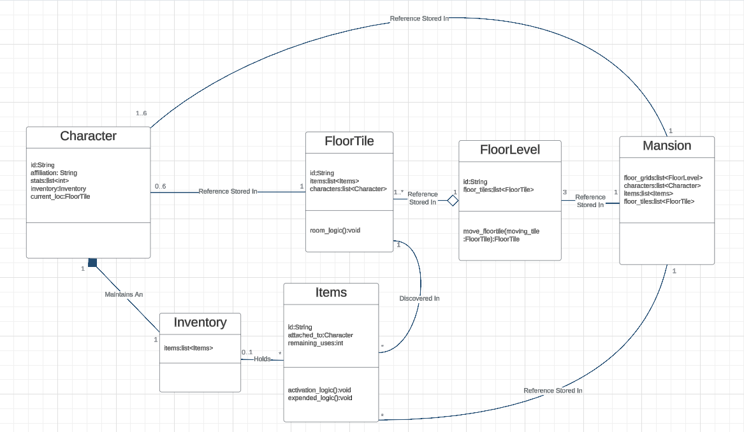

# The Midgame Stage Model

### The Midgame Stage model is representative of the different classes in play during a game of Betrayal Online and their relations to each other.

Betrayal at House on the Hill allows a maximum of six playable characters at play at one time. Every character has one inventory which stores a list of Items objects that the character has discovered from exploring different floor tiles around the mansion. Inventory objects are critical components to a Character object, without one, a Character object would not be able to perform critical game objectives. A Character object’s reference is stored inside the FloorTile object where they are standing as well as inside the Mansion object’s list of Character objects currently in play.

Inventory objects are assigned to an instance of a Character object and hold a list of references to any amount of attached Items objects.

Items objects have unique logic attached to them which will execute when the item gets activated by the player or when the character has expended all of the item’s available uses. Items objects can be found in certain FloorTile objects and then moved into a Character object’s Inventory object.

FloorTile objects contain lists of Character objects and Item objects that currently reside in that space. References to a floor’s FloorTile object are stored in that floor’s FloorLevel object and also in the Mansion object’s list of all FloorTile objects currently in play.

There are three different floor levels in a game of Betrayal at House on the Hill represented by three different FloorLevel objects. FloorLevel objects store a list of references to, at minimum, one starting FloorTile object which behaves as a component of the FloorLevel and cannot exist on the game board outside of a FloorLevel object. Specific FloorTile objects have the ability to move around to other positions in their FloorLevel, so to account for this, the attached FloorLevel object has a method to check for the unique and rare conditions in which a FloorTile object can be moved and to handle the moving of the FloorTile object to its destination.

There exists only one Mansion object for each game and acts like a record of the current state of the game. The Mansion object holds a list of references to all of the Character objects in play, all of the Items objects in play, all of the FloorTiles in play, as well as a reference to each of the three FloorLevel objects.

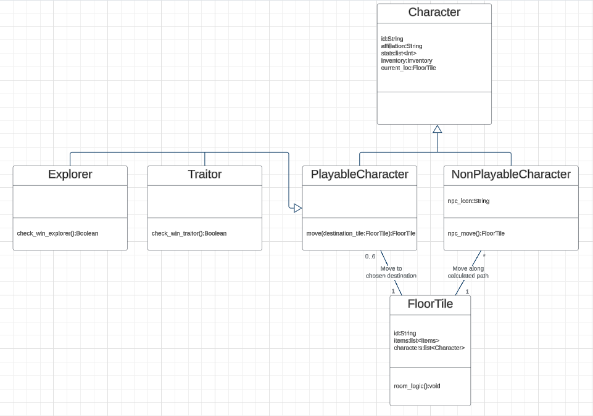

# The Multiple Characters Model

### The Multiple Characters Model represents the different classes inheriting from the Character class.

### 

The PlayableCharacter class is a child of the Character class and contains every attribute from the Character class as well as a method to move around to designated FloorTile objects, with a FloorTile object holding up to 6 PlayableCharacter objects (the maximum amount allowed in a game of Betrayal at House on the Hill). Inheriting from the PlayableCharacter class, The Explorer class and the Traitor class each contain unique methods to check if their specific win conditions have been met causing the game to end and their affiliation to be victorious.

The NonPlayableCharacter class is a child of the Character class. It has affiliation, stats and an inventory similar to its parent but The NonPlayableCharacter class has a unique method for movement, allowing a NonPlayableCharacter object to move along a defined, calculated route that separates it from the PlayableCharacter class. An example of a NonPlayableCharacter object’s unique movement includes moving back-and-forth between two specific floor tiles or towards the nearest Character of the opposite affiliation. Each FloorTile object can hold any amount of NonPlayableCharacter objects, from zero to the maximum amount of NonPlayableCharacter objects on the board.